



Project Title

Empowering India: Analysing the evolution of union budget allocations for sustainable growth

**Team ID: LTVIP2026TMIDS24962**

**Team Size: 4**

**Team Leader: Maddi Ganesh**

**Member:** **Satwik Vemuri**

**Team Member:** **Sobha Vinay Babu Merugumala**

**Team Member:** **Polimetla Naveen Kumar**

# INTRODUCTION

## Project Overview

This project explores the evolution of India’s Union Budget allocations from the fiscal years 2021–2022 to 2023–2024 using MySQL and Tableau. It focuses on analyzing ministry-wise, category-wise, and scheme-wise budget allocations, along with revenue and capital expenditure trends.

The interactive dashboards and storyboards help stakeholders understand government spending priorities, identify growth sectors, and derive insights to support strategic decision-making for industries such as renewable energy, electric vehicles, and pharmaceuticals.

## Purpose

The purpose of this project is to visualize Union Budget data to identify:

* Budget allocation trends across fiscal years
* Revenue vs Capital expenditure distribution
* Ministry-wise and scheme-wise investment patterns
* Growth sectors supporting sustainable development

Using Tableau’s interactive dashboards and MySQL database integration, the project provides a

structured analytical platform to explore and interpret government financial data efficiently.

# IDEATION PHASE

## Problem Statement

Organizations and businesses often lack clear visibility into government budget allocation trends across ministries and schemes. Without structured analysis, it becomes difficult to:

* + - Track investment growth patterns
    - Understand revenue and capital expenditure distribution
    - Make informed strategic business decisions

There is a need for a centralized, interactive dashboard that transforms raw budget data into meaningful insights.

## Empathy Map Canvas

**Who?**  
Policy analysts, business investors, renewable energy startups, EV manufacturers, pharmaceutical companies, and government policy observers who rely on structured financial insights for planning and decision-making.

**Think & Feel?**  
They seek clarity in government spending patterns, want confidence in investment planning, and prefer simplified, visual interpretations of complex Union Budget data.

**See?**  
Large volumes of raw financial data, lengthy budget reports, scattered information across documents, and limited tools for easy year-wise comparison.

**Hear?**  
Growing emphasis on sustainable development, government initiatives supporting innovation and infrastructure, and the importance of data-driven strategic decisions.

**Say & Do?**  
Explore interactive dashboards, apply filters to compare fiscal years, analyze ministry-wise and scheme-wise allocations, and use visual insights to guide business strategies.

**Pain?**Lack of a centralized analytical platform, difficulty comparing multiple fiscal years, challenges in understanding revenue vs capital expenditure distribution, and limited accessibility to simplified insights.

**Gain?**  
A one-stop interactive dashboard, clear visualization of budget allocation trends, faster comparative analysis, improved investment decision support, and deeper understanding of India’s economic priorities and growth sectors.

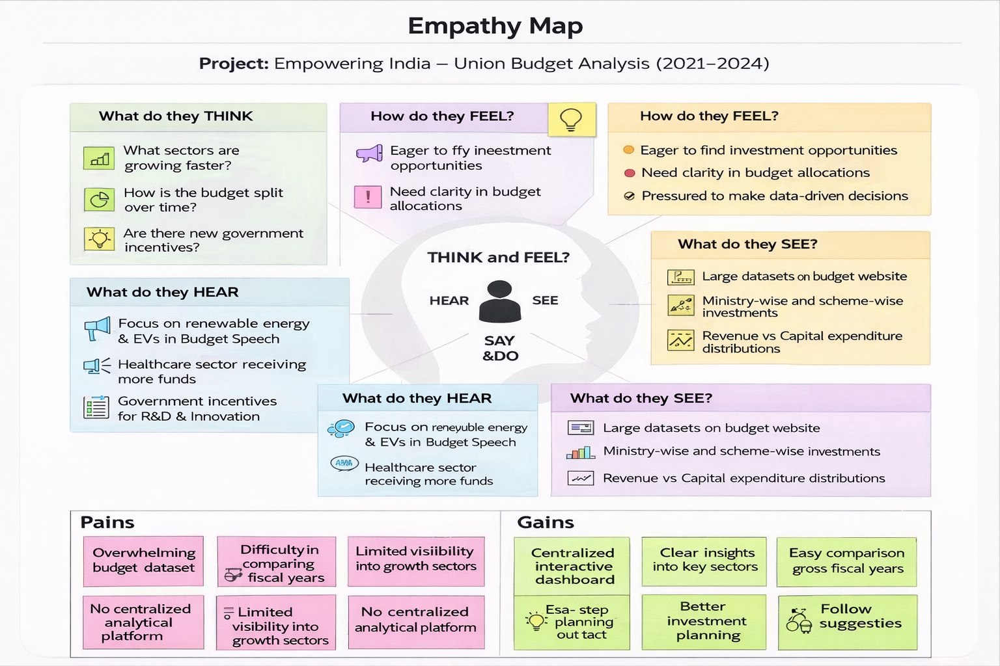

## Brainstorming

Use Tableau to create interactive dashboards for Union Budget analysis  
• Analyze year-wise budget growth (2021–2024)  
• Compare Revenue vs Capital expenditure trends  
• Identify top and low funded ministries  
• Visualize category-wise and scheme-wise allocations  
• Use bar charts, treemaps, and line charts for comparison  
• Enable filters for Year, Ministry, and Category  
• Embed dashboard into Flask web application

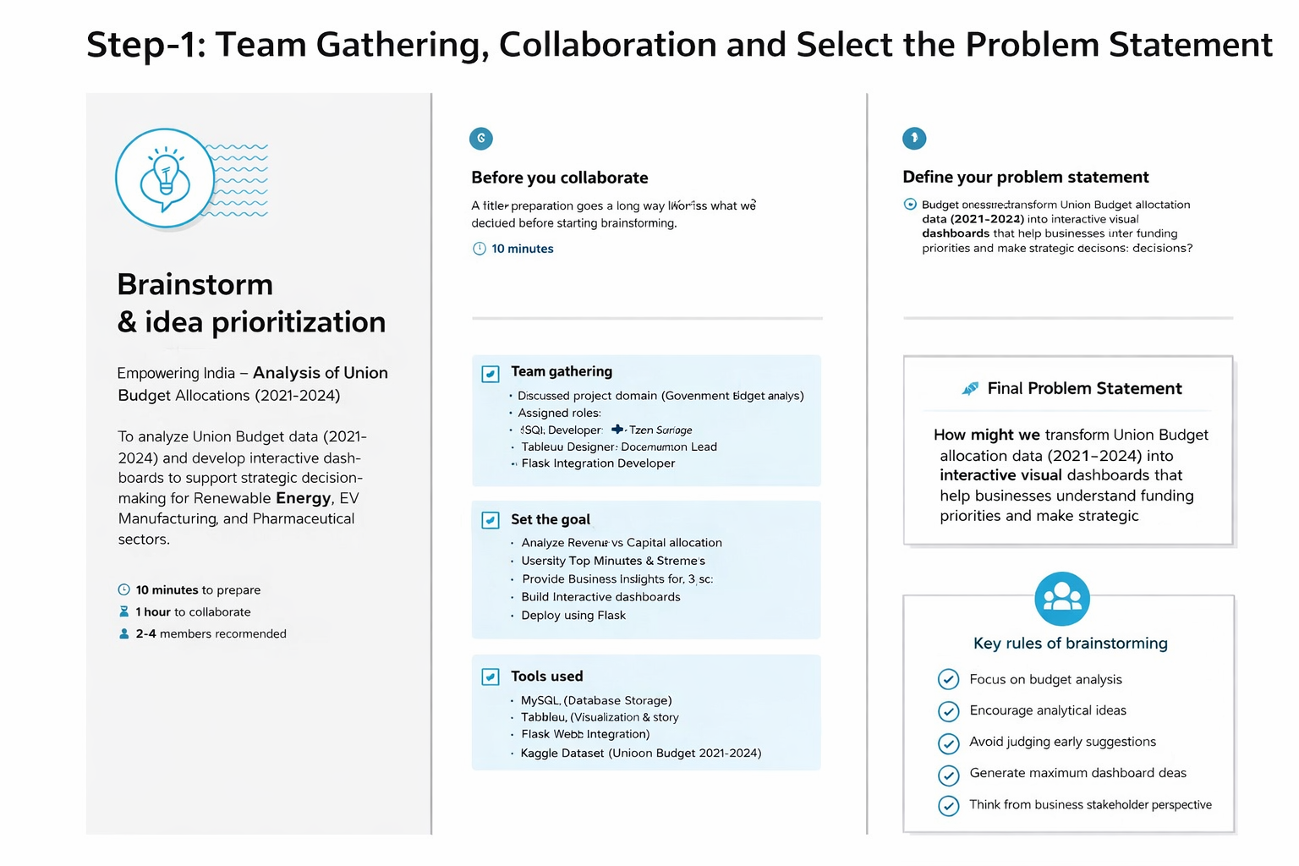

# REQUIREMENT ANALYSIS

* 1. **Customer Journey Map**

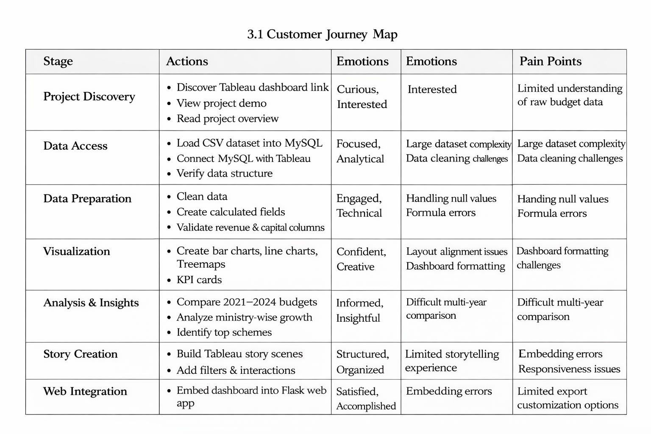

* 1. **Solution Requirement**

|  |  |  |
| --- | --- | --- |
| **FR**  **No.** | **Functional Requirement (Epic)** | **Sub Requirement (Story / Sub-Task)** |
| FR-1 | Data Collection & Storage | * Import Union Budget dataset (2021–2024) * Store data in MySQL Database * Validate data integrity before storage |
| FR-2 | Data Preprocessing | * Clean null values * Format revenue & capital columns * Create calculated fields (Total Budget, Growth %) |
| FR-3 | Dashboard Visualization | * Category-wise budget visualization * Ministry-wise allocation analysis * Scheme-wise comparison charts |
| FR-4 | Comparative Analysis | * Compare Actual vs Estimated vs Revised budgets * Year-wise trend analysis (2021–2024) |
| FR-5 | Filtering & Interaction | * Filter by Financial Year * Filter by Ministry / Category * Drill-down into schemes |
| FR-6 | Story & Insights | * Create Tableau Story with multiple scenes * Highlight top 5 ministries & schemes * Show budget growth trends |
| FR-7 | Web Integration | * Embed Tableau Dashboard in Flask UI * Enable interactive dashboard view on web application |
| FR-8 | Reporting & Export | * Allow users to download reports/screenshots * Provide summary insights for decision-making |

* 1. **Data Flow Diagram**

**Kaggle Union Budget CSV Dataset → MySQL Database → SQL Data Processing → Tableau Visualization → Interactive Dashboard → Flask Web Deployment → Insights & Decision Support**

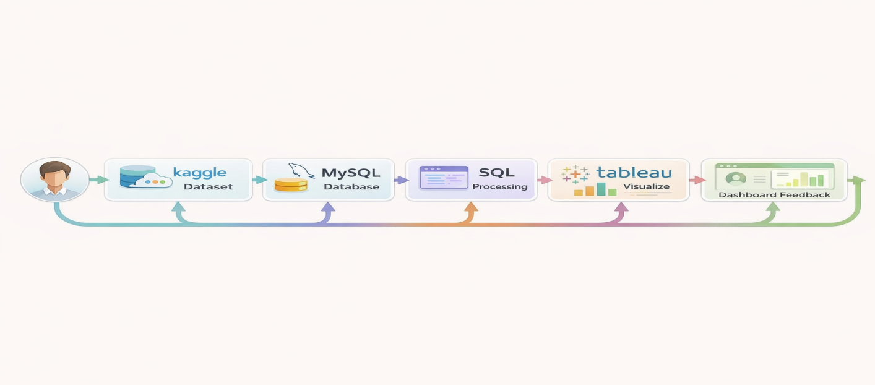

* 1. **Technology Stack**
     + **Tool**: Tableau
     + **Language**: Drag-and-drop interface (with SQL for data processing)
     + **Data**: CSV – India Union Budget Dataset (2021-2024)

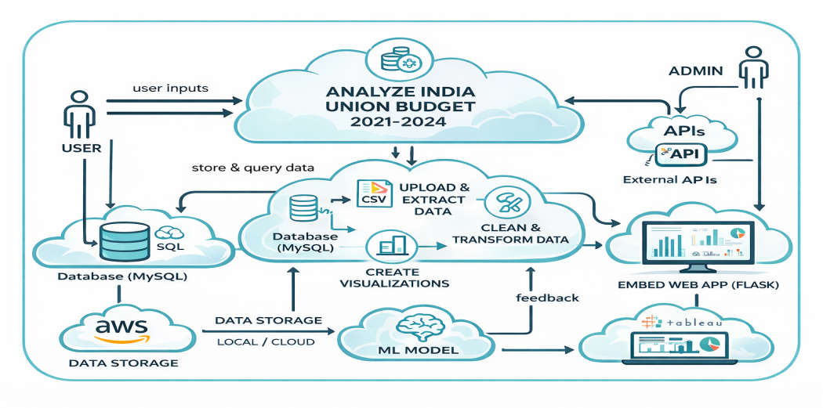

# PROJECT DESIGN

## Problem Solution Fit

The project focuses on transforming raw Union Budget data into meaningful visual insights using Tableau’s interactive dashboards and analytical capabilities.

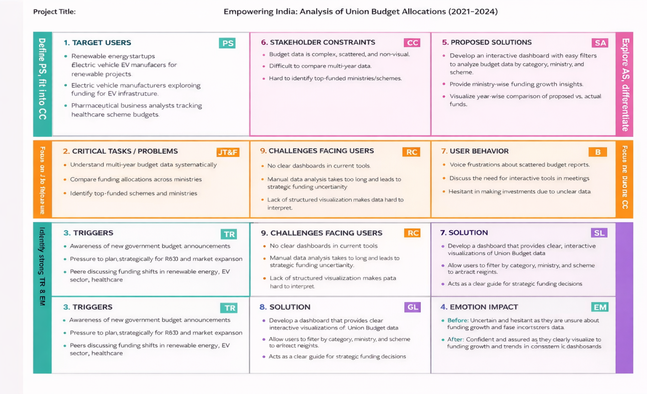

## Proposed Solution

An interactive Tableau dashboard and storyboard to showcase Union Budget trends (2021–2024), ministry-wise and scheme-wise allocations, revenue vs capital expenditure comparison, and identification of top-funded sectors to support strategic decision-making.

|  |  |  |
| --- | --- | --- |
| **S.No.** | **Parameter** | **Description** |
| 1. | Problem Statement (Problem to be solved) | Business stakeholders, renewable energy startups, EV manufacturers, and pharmaceutical companies lack clear and interactive insights into Union Budget allocations (2021–2024). The complexity of ministry-wise, category-wise, and scheme-wise budget data makes it difficult to analyze funding trends and make strategic investment decisions. |
| 2. | Idea / Solution description | The project provides a SQL-based data management system integrated with Tableau dashboards to visualize Union Budget allocations. It presents ministry-wise, scheme-wise, category-wise, revenue vs capital comparisons, and year-wise trends through interactive dashboards and stories to support data-driven decision-making. |
| 3. | Novelty / Uniqueness | Combines multi-year Union Budget data (2021–2024) with structured SQL processing and interactive Tableau visualization. Includes calculated fields, filters, Top-5 comparisons, revenue vs capital analysis, and integrated web deployment using Flask for enhanced accessibility. |
| 4. | Social Impact / Customer Satisfaction | Improves transparency and understanding of government budget allocations. Helps startups and industries align their strategies with national priorities such as renewable energy, EV adoption, and healthcare development. Encourages informed, data-driven strategic planning. |
| 5. | Business Model (Revenue Model) | Can be extended as a subscription-based analytics platform providing advanced sector-specific insights, premium forecasting features, downloadable reports, and API-based access for enterprises or research institutions. |
| 6. | Scalability of the Solution | Easily scalable by incorporating additional fiscal years, integrating real-time government data sources, adding predictive analytics (ML models), sector-specific deep analysis, and expanding to state budget analysis for more granular insights. |

## Solution Architecture

* + - **Input**: India Union Budget Dataset (2021–2024) – CSV
    - **Process**: Import into MySQL → Perform SQL Queries & Data Cleaning → Connect to Tableau → Create Visualizations → Build Interactive Dashboard & Story
    - **Output**: Interactive Dashboards + Story Scenes + Web-Embedded Insights (Flask)

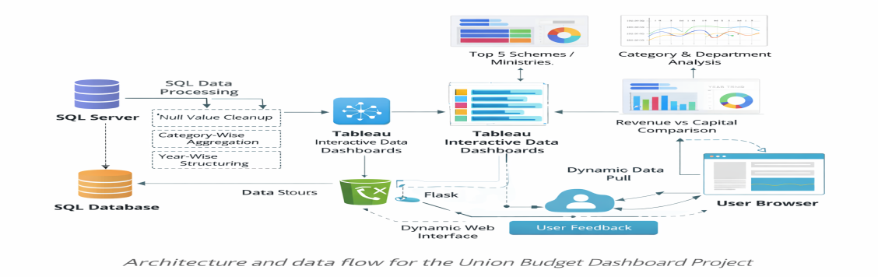

# PROJECT PLANNING & SCHEDULING

* 1. **Project Planning**

|  |  |  |
| --- | --- | --- |
| **Phase** | **Timeline** | **Tools Used** |
| Dataset Collection (Union Budget 2021–2024) | Day 1 | |  | | --- | |  |  |  | | --- | | Kaggle, CSV | |
| Database Setup & Data Import | Days 2 | MySQL Workbench |
| SQL Processing & Data Cleaning | Day 3 | MySQL (SQL Queries) |
| Visualization Creation | Day 4-5 | Tableau |
| Dashboard & Story Design | |  | | --- | |  |  |  | | --- | | Day 6 | | Tableau |
| Web Integration & Deploymen | Day 7 | Flask, HTML |

|  |  |  |  |  |  |  |
| --- | --- | --- | --- | --- | --- | --- |
| **Sprint** | **Total Story Points** | **Duration** | **Sprint Start Date** | **Sprint End Date (Planned)** | **Story Points Completed (as on**  **Planned End Date)** | **Sprint Release Date (Actual)** |
| **Sprint- 1** | 10 | 3 days | 01 Feb 2026 | 3 Feb 2026 | 10 | 03 Feb 2026 |
| **Sprint- 2** | 11 | 3 days | 04 Feb 2026 | 06 Feb 2026 | 11 | 06 Feb 2026 |
| **Sprint- 3** | 10 | 3 days | 07 Feb 2026 | 09 Feb 2026 | 10 | 09 Feb 2026 |
| **Sprint- 4** | 08 | 3 days | 10 Feb 2026 | 12 Feb 2026 | 08 | 12 Feb 2026 |

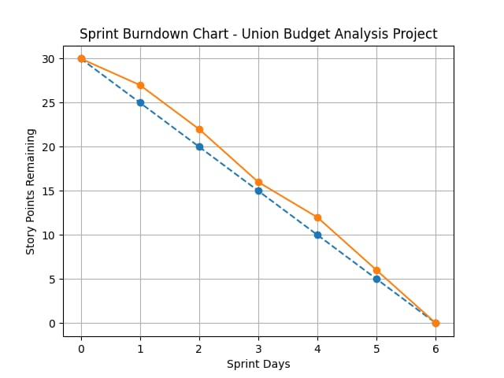

# FUNCTIONAL AND PERFORMANCE TESTING

## Performance Testing

* + - **Dashboard Loading Time**: Less than 2 seconds

|  |  |  |
| --- | --- | --- |
| **S.No** | **Parameter** | **Screenshot / Values** |
| 1. | **Data Rendered** | Category, Ministry, Scheme, Actual Revenue (2021–22), Actual Capital (2021–22), Total Budget (2021–22), Estimated Revenue (2022–23), Revised Estimates (2022–23), Budget Estimates (2023–24) |
| 2. | **Data Preprocessing** | Removed null values, standardized column names, formatted currency values, verified data types (numeric/string), structured year-wise data |
| 3 | **Utilization of Filters** | Year Filter (2021–22, 2022–23, 2023–24), Category Filter, Ministry Filter, Scheme Filter |
| 4 | **Calculated Fields Used** | Total Investment (All Years), Revenue vs Capital Difference, Year-wise Growth %, Top 5 Ranking (Ministry/Scheme), Budget Share % |
| 5 | **Dashboard Design** | No. of Visualizations / Graphs – 7 (Top 5 Schemes, Top 5 Ministries, Category-wise Budget, Department-wise Budget, Scheme-wise Budget, Total Investment KPI, Revenue vs Capital Comparison) |
| 6 | **Story Design** | No. of Scenes – 5 (Introduction, Category Analysis, Ministry Analysis, Scheme Analysis, Conclusion & Business Insights) |

# RESULTS

## Top 5 Schemes – 2021–2022

Treemap chart showing the highest funded schemes in FY 2021–22 based on total budget allocation,

highlighting major government spending priorities and sector focus areas.

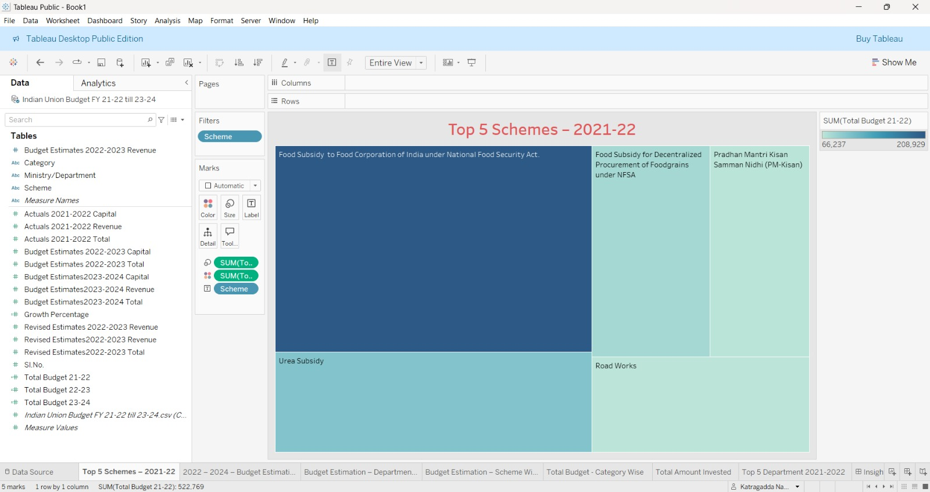

## 2022–2024 Budget Estimation – Category Wise

Heatmap chart comparing total budget allocations across different demand categories for FY 2022–23 and FY 2023–24, highlighting year-wise changes and identifying categories with increased or decreased funding.

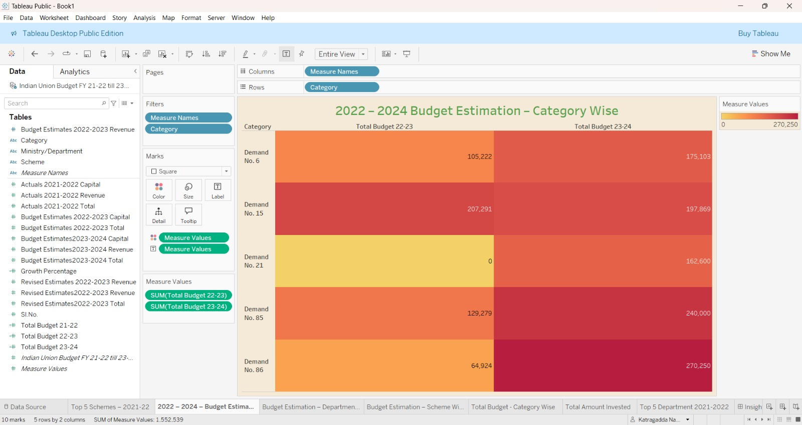

## 2022–2024 Budget Estimation – Department Wise

Bar chart comparing total budget allocations across major ministries/departments for FY 2022–23 and FY 2023–24, highlighting funding variations and identifying departments with increased or decreased allocations.

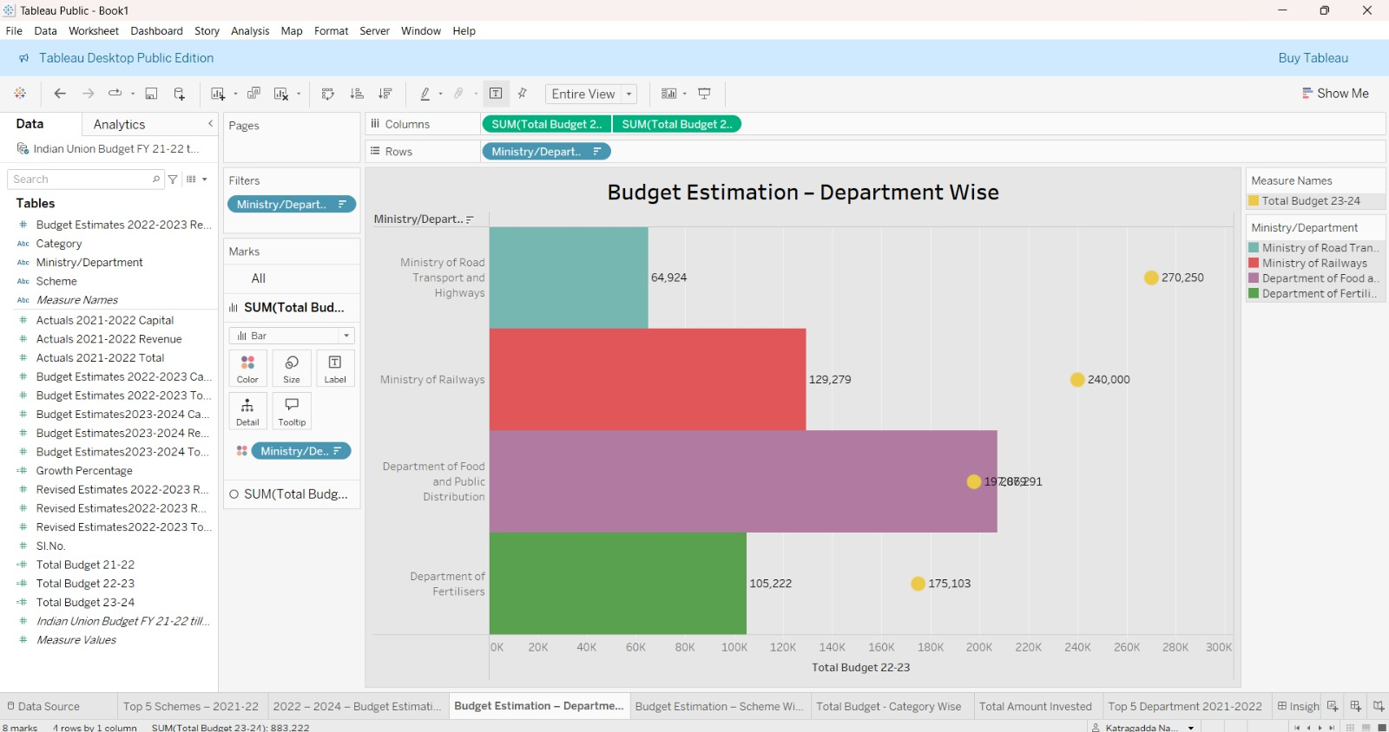

## 2022–2024 Budget Estimation – Scheme Wise

Bar chart comparing total budget allocations for major government schemes across FY 2022–23 and FY 2023–24, highlighting year-wise funding changes and identifying schemes with increased or decreased allocations

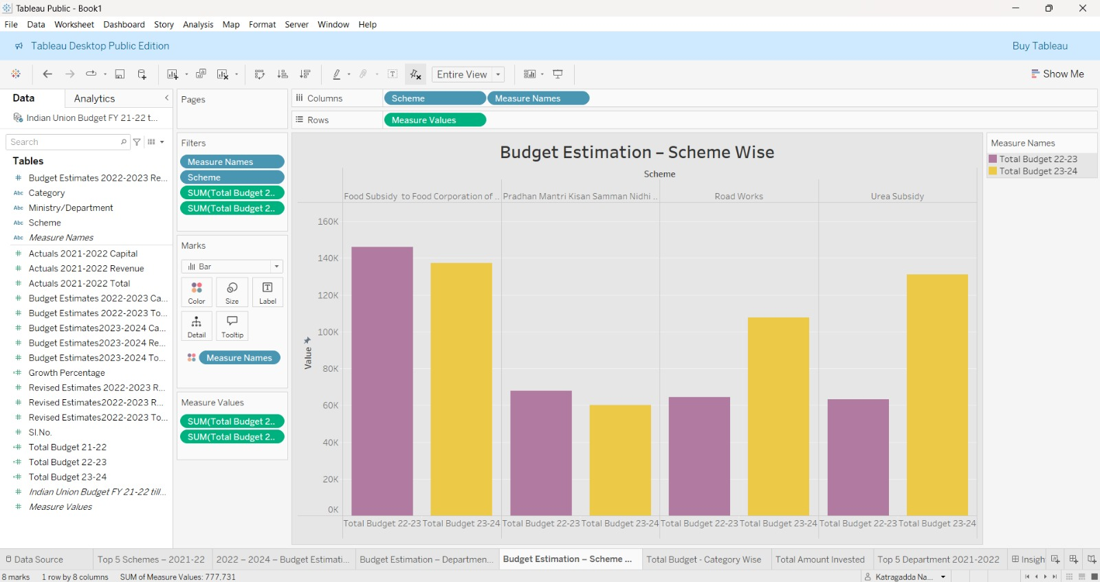

## Top 5 Departments – 2021–2022

Bubble chart displaying the top five ministries/departments based on total budget allocation for FY 2021–22, highlighting the highest funded sectors and their relative spending proportions.

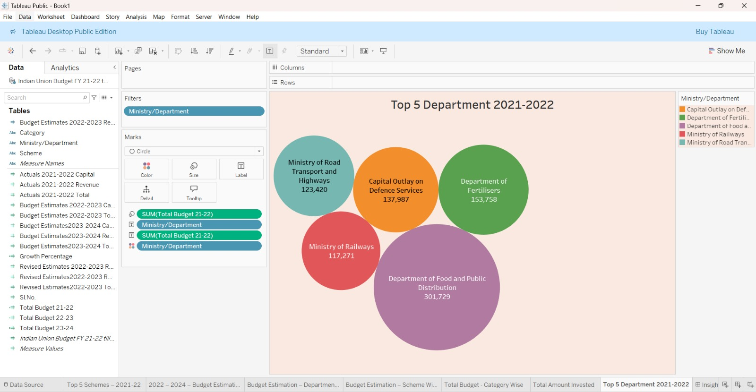

## Total Amount Invested – 2021–2022

KPI text chart displaying total capital expenditure, revenue expenditure, and overall budget allocation for FY 2021–22, providing a consolidated view of government spending.

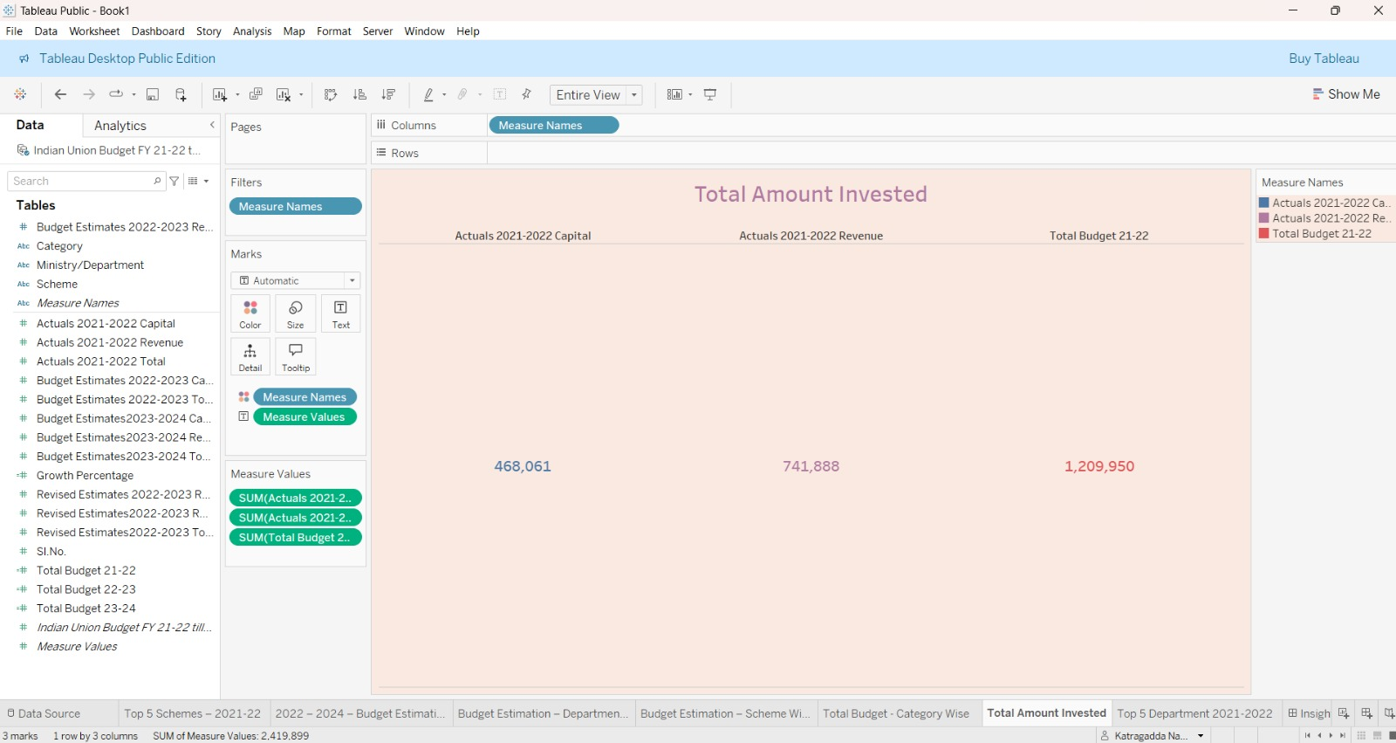

**7.6 Total Budget – Category Wise (2023–2024)**

Scatter (symbol) chart displaying total budget allocations across different demand categories for FY 2023-24,highlighting funding distribution and identifying categories with the highest and lowest allocations**.**

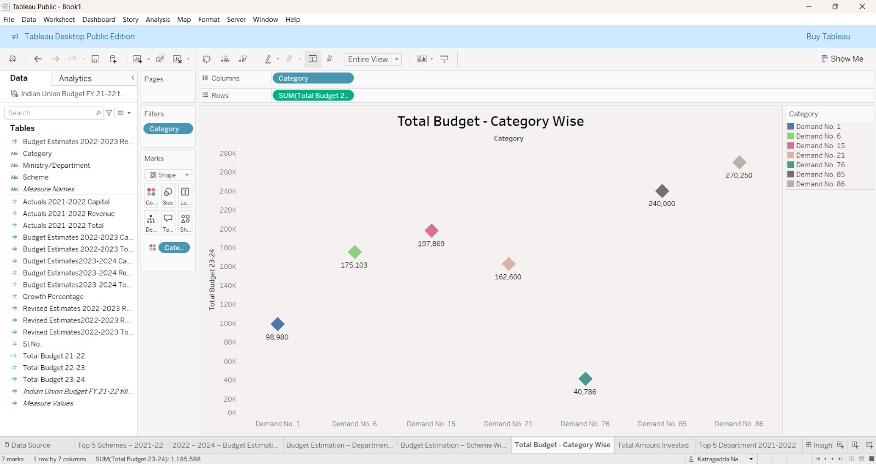

## Dashboard View

Full Tableau Dashboard

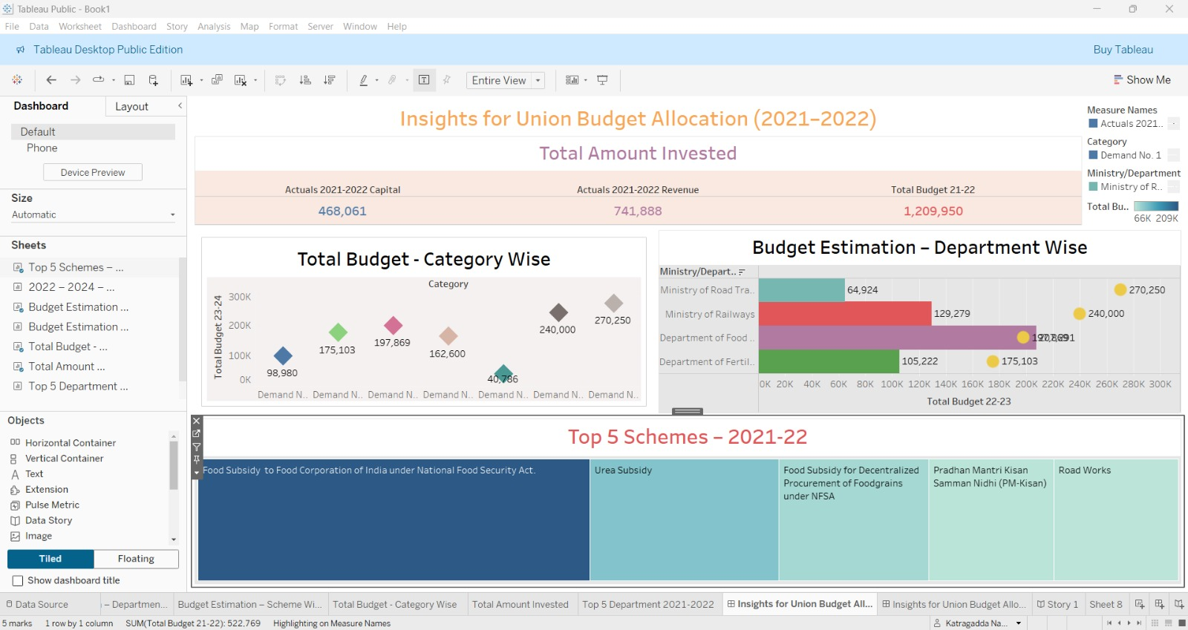

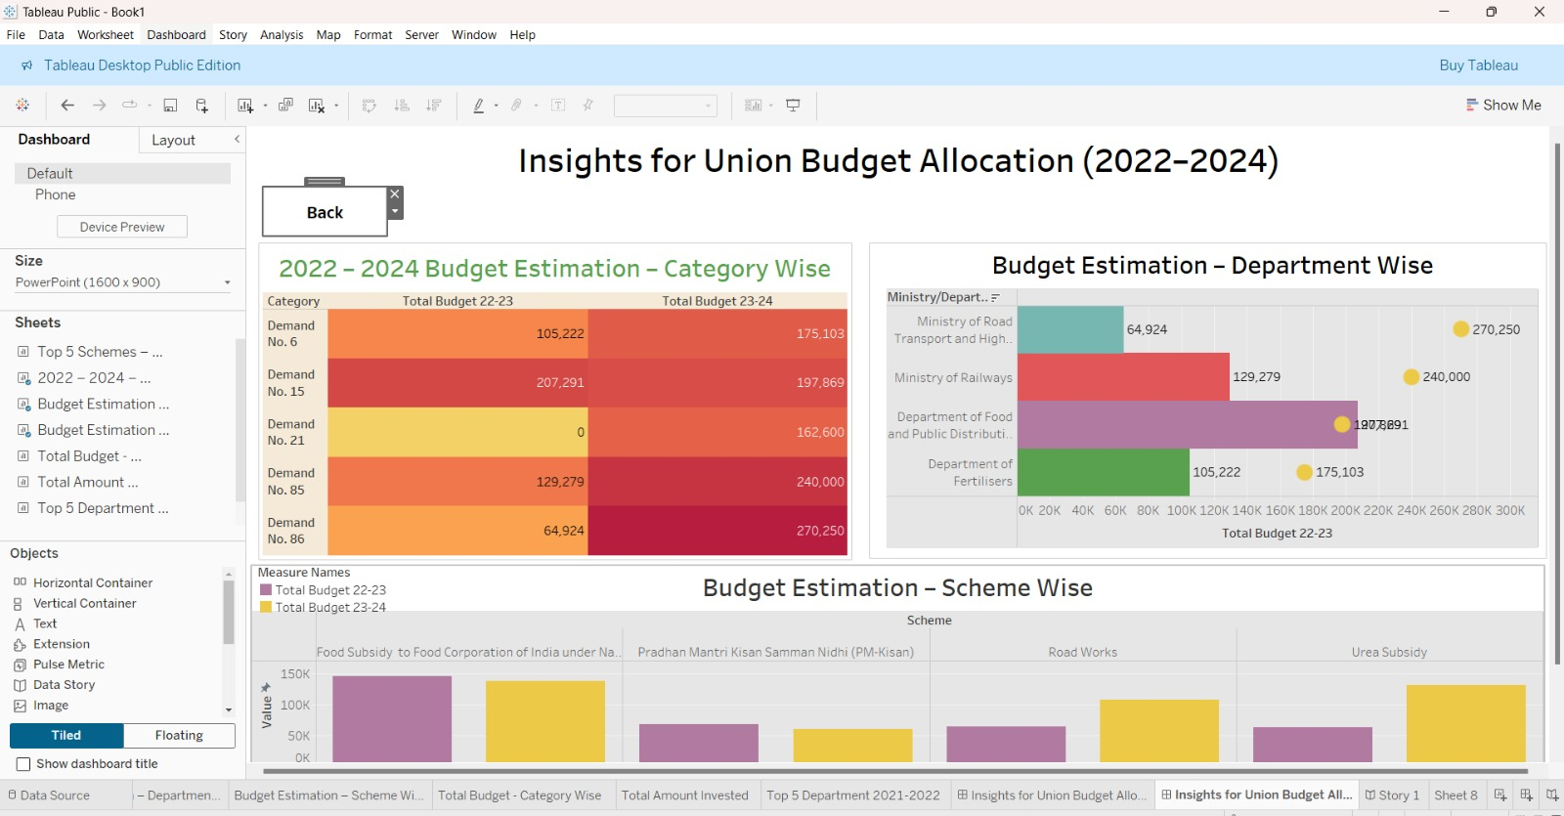

**7.8 Storyboard View**

Story point with navigation tabs

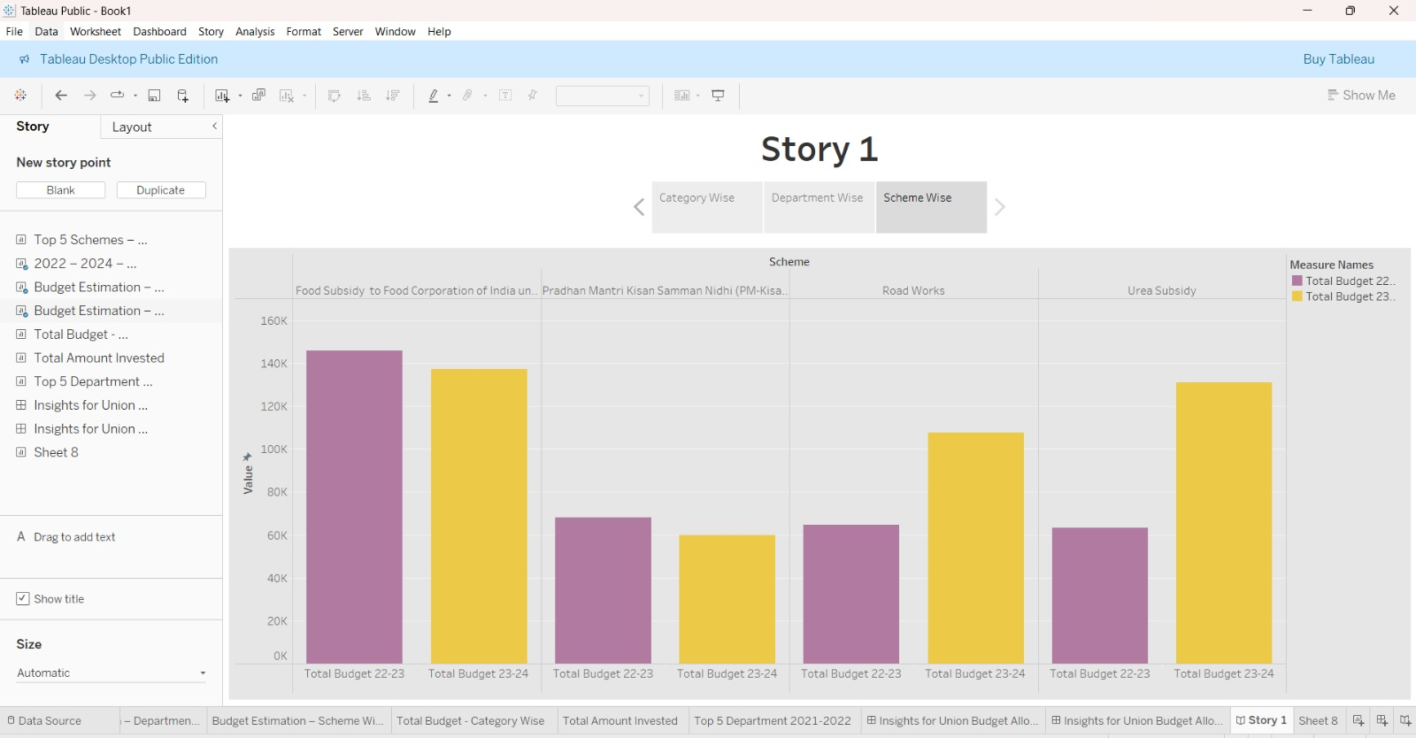

* 1. **Performance Testing**

Amount of Data Loaded

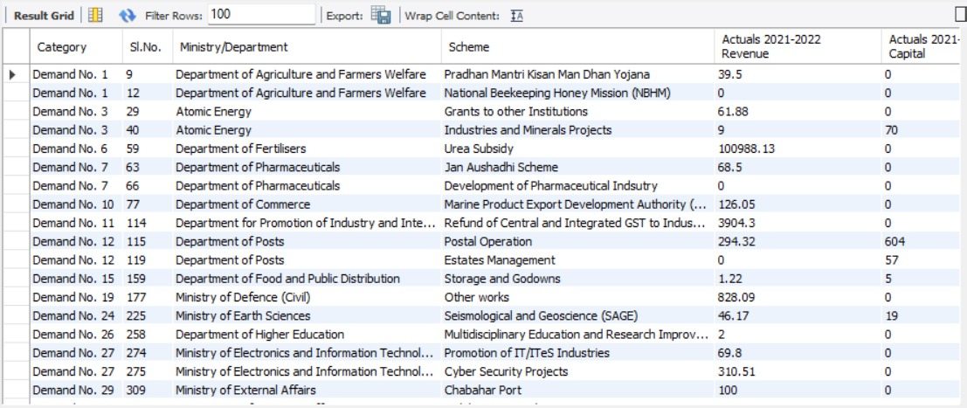

**Utilization of Data Filters**

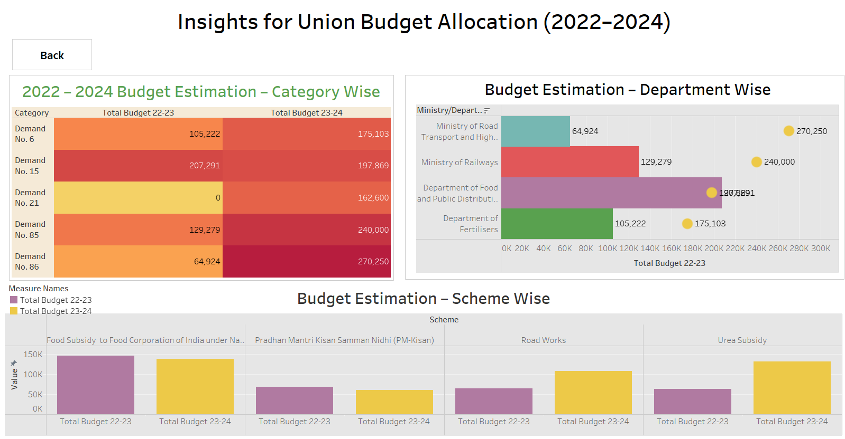

**No of Calculation Fields**

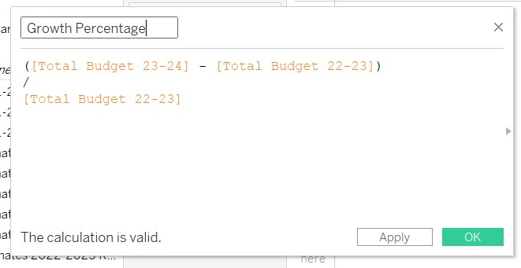

**No of Visualizations/ Graphs**

Total Amount Invested

Total Budget- Category Wise

Top 5 Department/Ministry Wise for 2021-2022

Top 5 Schemes 2021-2022

2022 – 2024 – Budget Estimation – Category Wise

2022 – 2024 – Budget Estimation – Department Wise

2022 – 2024 – Budget Estimation – Scheme Wise

**Web integration**

**Dashboard and Story embed with UI With Flask**

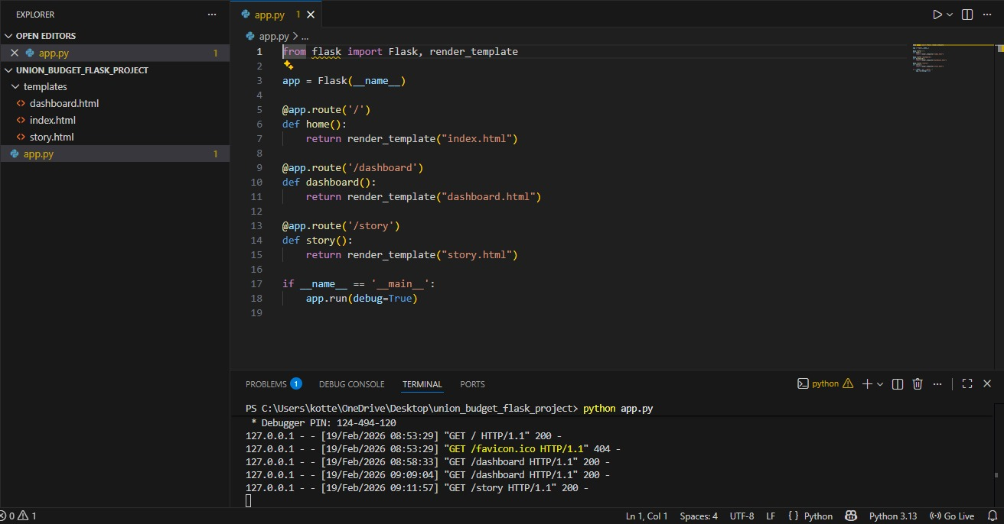

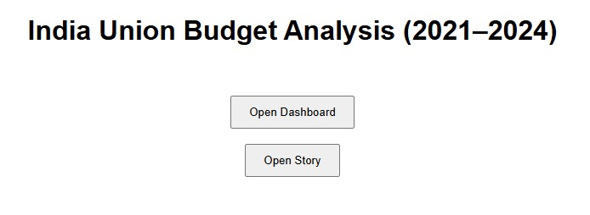



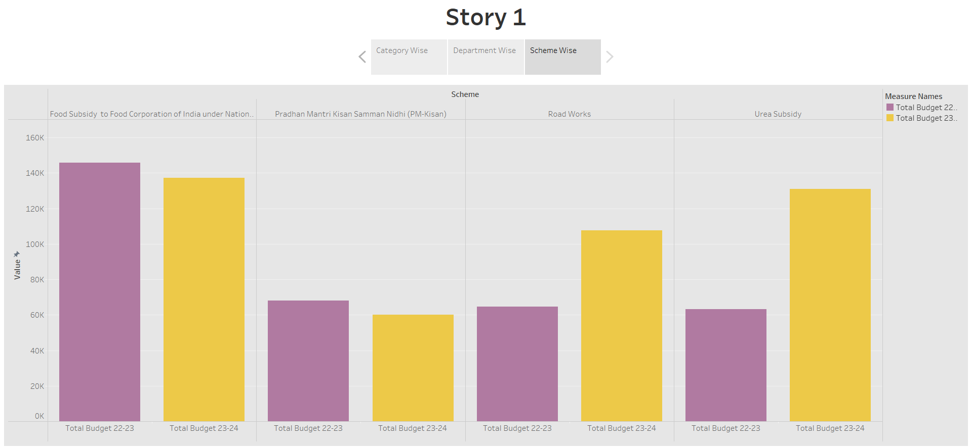

**PROJECT DEMO VEDIO LINKS:**

[**https://drive.**google**.com/file/d/1XDTJctPviG_vQaTBEEYeP8DDPqHtWwBX/view?usp=drivesdk**](https://drive.google.com/file/d/1XDTJctPviG_vQaTBEEYeP8DDPqHtWwBX/view?usp=drivesdk)

[**https://drive.google.com/file/d/173qDa5-Mi9MxwbhqodUfy7wetAp-yG-y/view?usp=drivesdk**](https://drive.google.com/file/d/173qDa5-Mi9MxwbhqodUfy7wetAp-yG-y/view?usp=drivesdk)

# 8 ADVANTAGES & DISADVANTAGES

## Advantages

## Interactive and dynamic dashboards for Union Budget analysis

## Easy comparison of fiscal years (2021–2024)

## Clear visualization of ministry-wise and scheme-wise allocations

## Revenue vs Capital expenditure analysis made simple

## Fast insights using Tableau without heavy programming

## Disadvantages

## Limited customization outside Tableau environment

## Tableau Public has sharing and data privacy limitation

## No built-in advanced predictive analytics (requires additional ML integration)

## Performance may reduce with very large datasets

# 9 CONCLUSION

The Tableau-based Union Budget Analysis system successfully transforms complex government financial data (2021–2024) into clear, interactive visual insights, enabling better understanding of budget trends, ministry-wise allocations, and revenue vs capital expenditure patterns to support informed strategic and investment decisions.

# 10 FUTURE SCOPE

* Integration with live government open-data APIs
* Budget forecasting and predictive analytics using Python / Machine Learning
* Enhanced mobile-responsive dashboard design
* Advanced export functionality (PDF/Excel reports)
* Integration of additional fiscal years for long-term trend analysis
* Real-time policy impact comparison dashboards

# 11 APPENDIX

## Source Code

Data processing performed using MySQL (SQL Queries) and visualization developed using

Tableau’s drag-and-drop interface. Web integration implemented using Flask and HTML

## Dataset Link

## Dataset: India Union Budget (FY 2021–2022 to FY 2023–2024) – Kaggle CSV Dataset

## <https://www.kaggle.com/datasets/prasenjitsharma/indian-union-budget-fy-21-22-till-23-24>

## TABLEAU PUBLIC DASHBOARD AND STORY LINKS:

## DASHBOARD LINK:

## <https://public.tableau.com/views/Book1_17714001947740/InsightsforUnionBudgetAllocation20222024?:language=en-US&publish=yes&:sid=&:redirect=auth&:display_count=n&:origin=viz_share_link>

## STORY LINK:

## <https://public.tableau.com/views/Book1_17714001947740/Story1?:language=en-US&:sid=&:redirect=auth&:display_count=n&:origin=viz_share_link>

## 